Samantha Coleman

Full Sail University

Milestone 4: Microsoft PowerShell

27th February 2025

Table of Contents

**Microsoft PowerShell** 3

**Part 1: Setting Up** 3

**Step 1** 3

**Step 2** 4

**Step 3** 5

**Part 2: Install and uninstall server roles using PowerShell** 6

**Step 1** 6

**Step 2** 6

**Step 3** 7

**Step 4:** 7

## **Microsoft PowerShell**

Microsoft PowerShell is a versatile tool which enables significant improvement to server configuration efficiency. This document provides step by step instructions to utilize PowerShell CLI to configure a Windows Server 2019.

## **Part 1: Setting Up**

**Step 1**: Create a new (or repurposed) Windows Server 2019 VM, and assign the following IP address configuration using PowerShell.  
Already we are using proxmox and thus Windows Server 2019 is already installed.

To assign IP address and its members, use this command: ***New-NetIPAddress -InterfaceAlias "Ethernet" -IPAddress 192.168.50.5 -PrefixLength 24 -DefaultGateway 192.168.50.2***

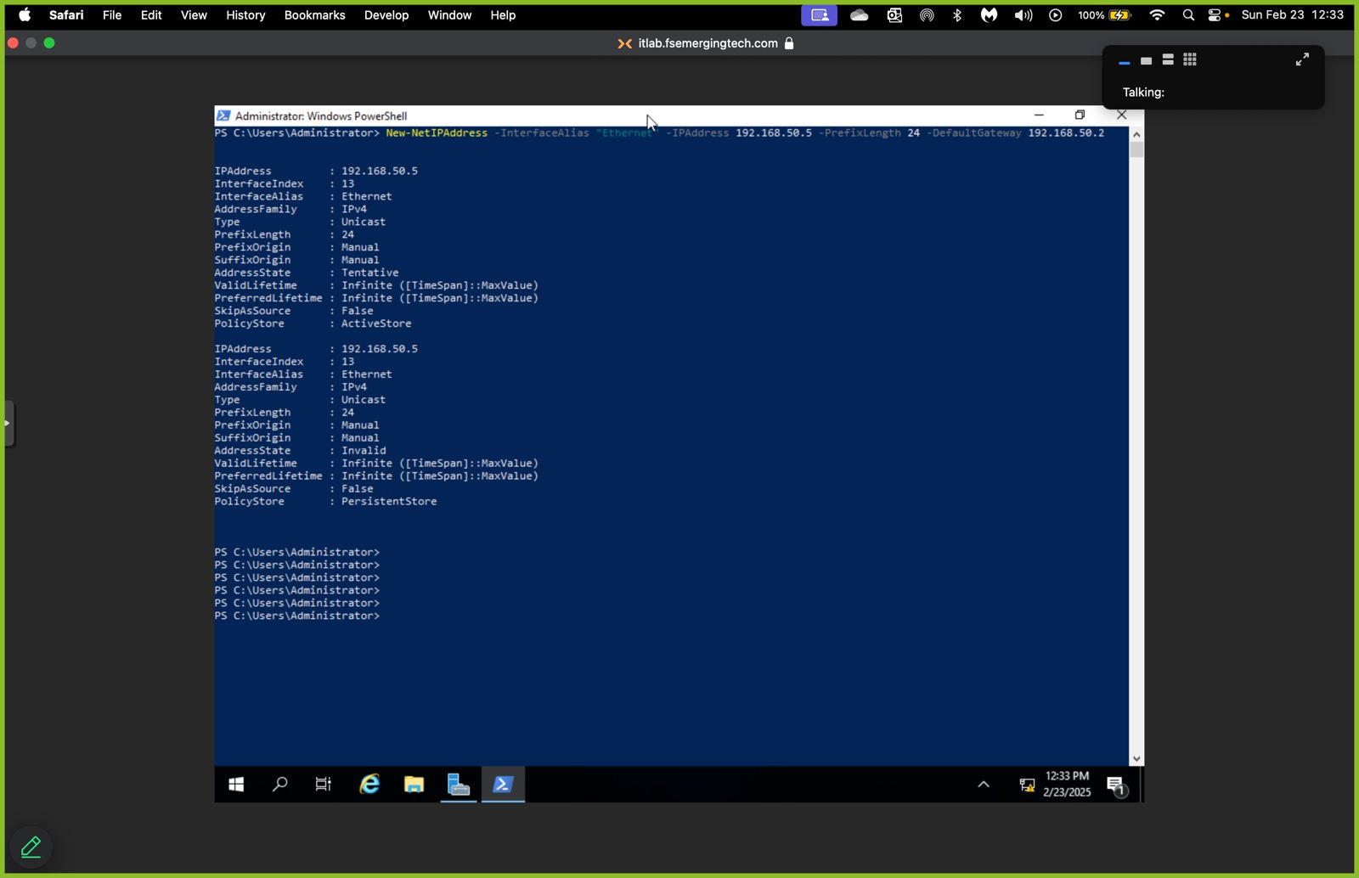 This commands assigns both IP address and default gateway.

d.) Setting DNS server:

Command: ***Set-DnsClientServerAddress -InterfaceAlias "Ethernet" -ServerAddresses 192.168.50.2***

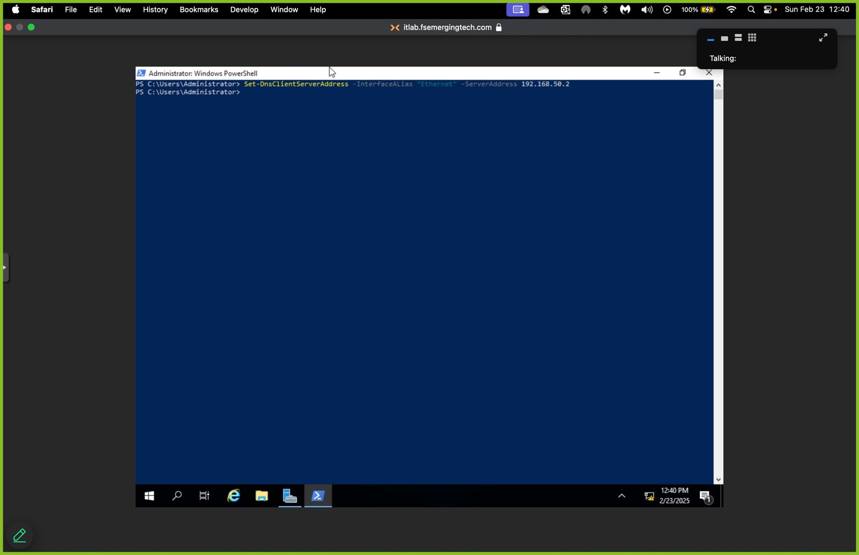

**Step 2:** Rename the server to CoreServer using PowerShell. Go to the GUI (Server Manager) to verify name change. The computer needs to be restarted.

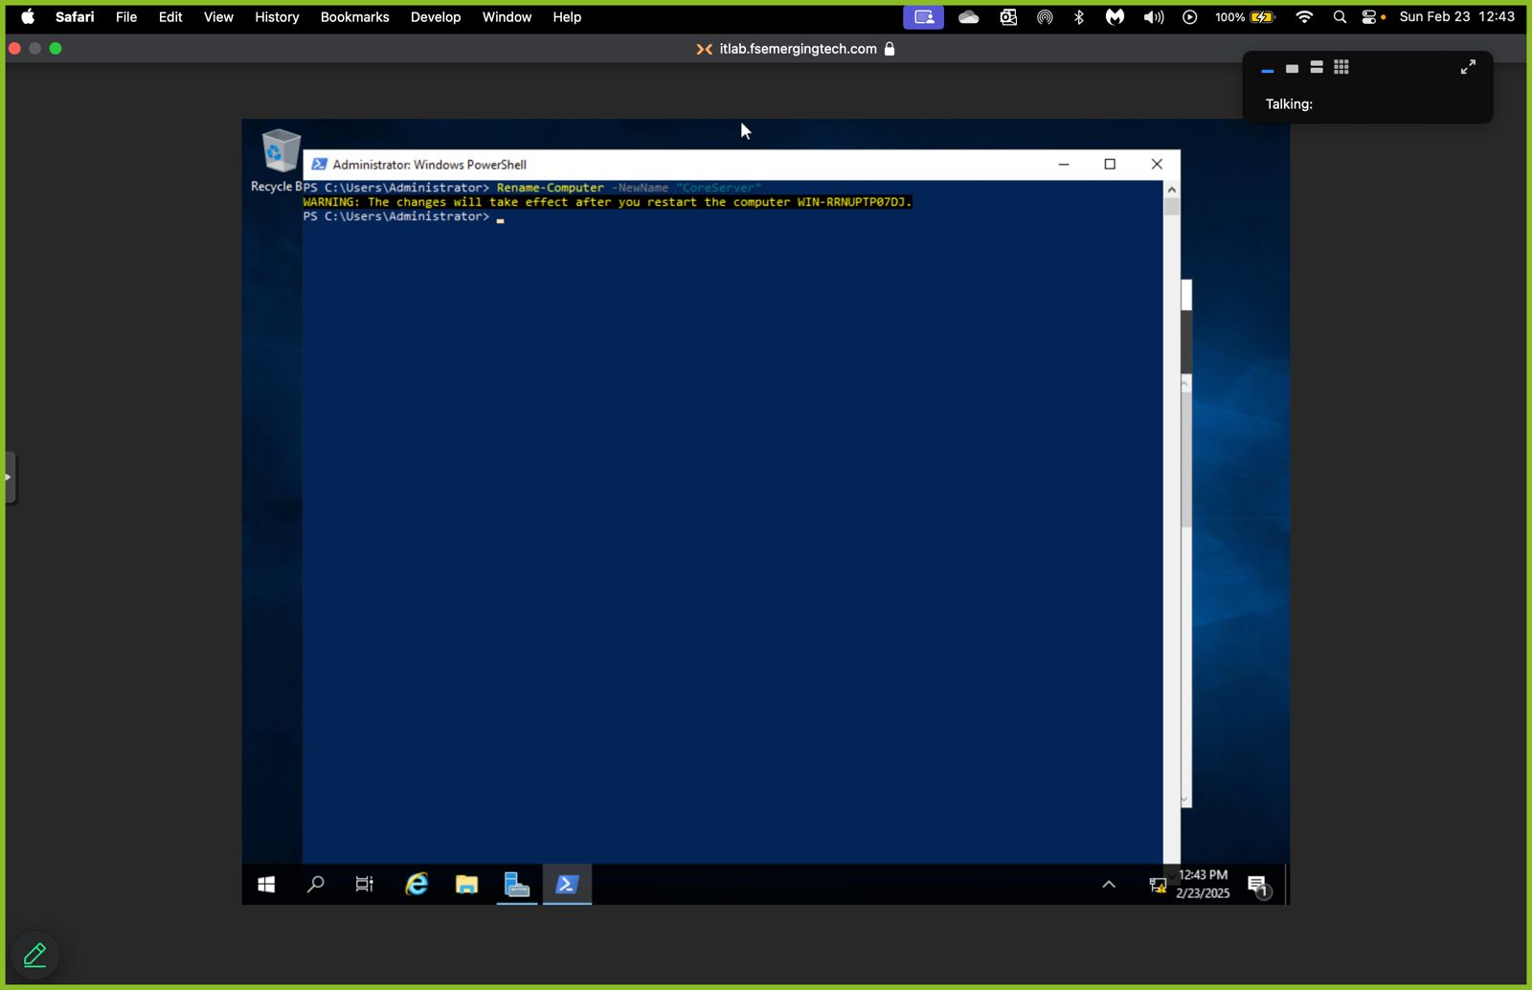

**Step 3:** Use the “sconfig” command in PowerShell to disable automatic updates.

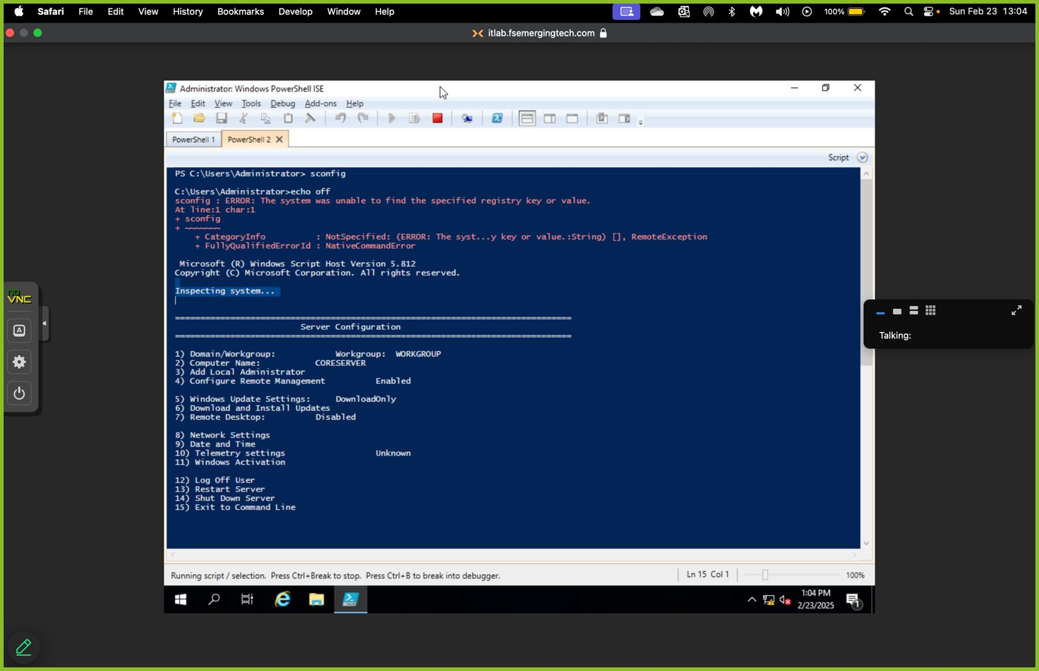After you type sconfig then press enter, then navigate to number 5,the option for windows update settings.

Even though this option was not working, I used an alternative command;  
***Set-Service -Name wuauserv -StartupType Disabled***

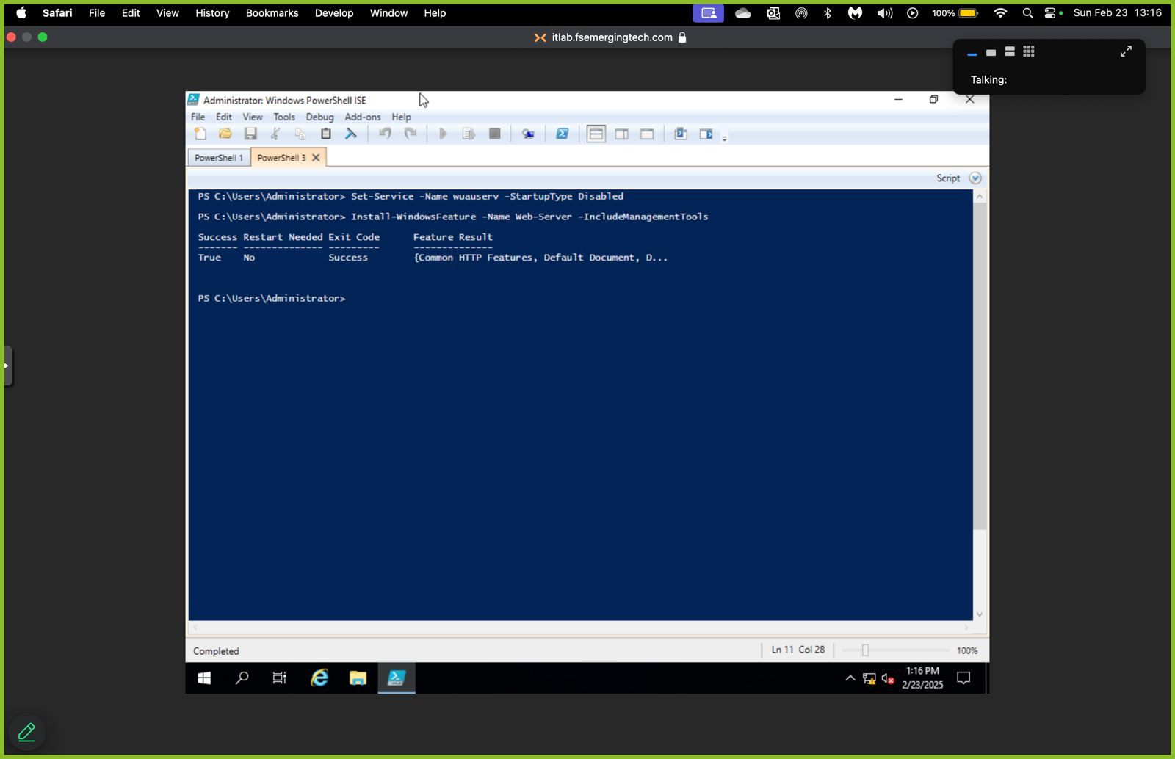

## **Part 2: Install and uninstall server roles using PowerShell**

**Step 1**:Install the “web server (IIS)” role.

Use this command***: Install-WindowsFeature -Name Web-Server -IncludeManagementTools***



**Step 2**: Verify/confirm the change through the GUI that the role has been added. Naviagte to Manage, then Server roles and you will see The Web Server (IIS) has been checked, meaning it installed successfully.

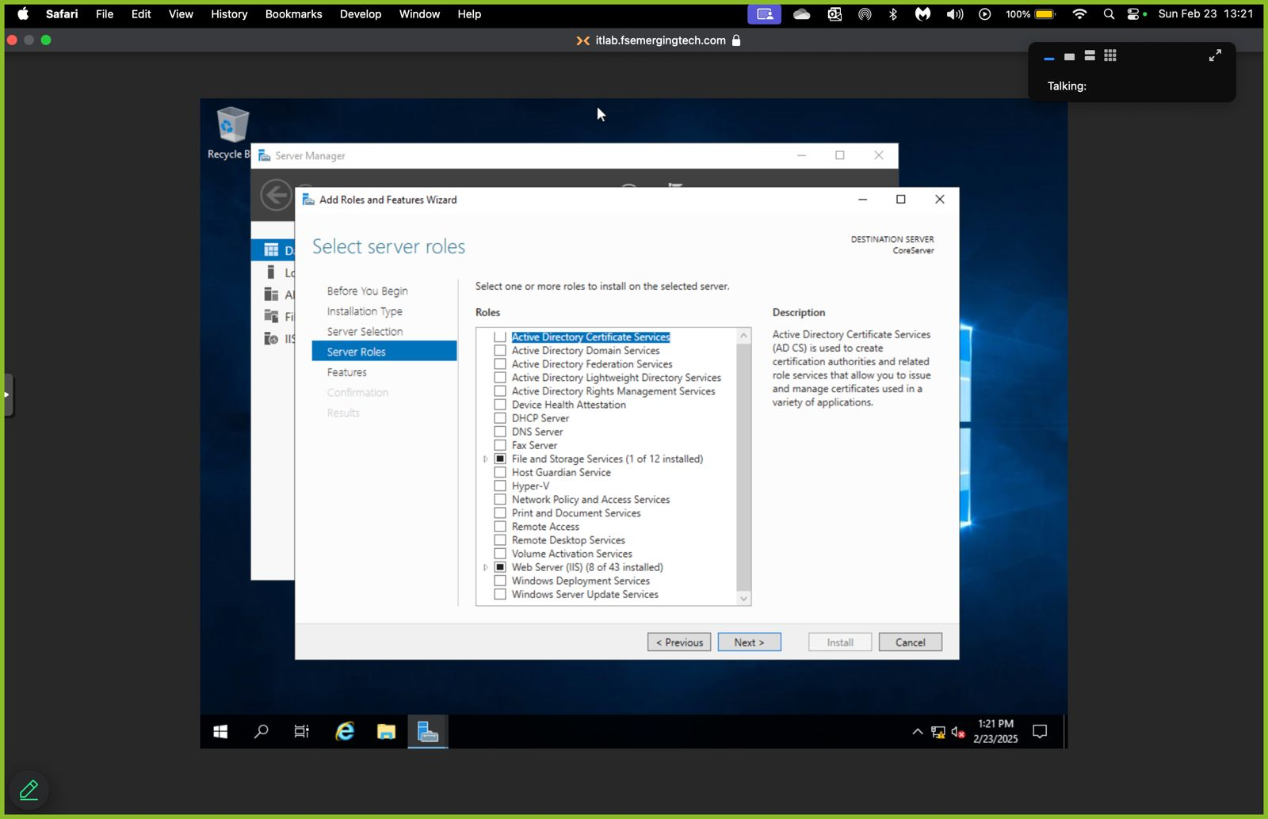

**Step 3**: Uninstall “web server (IIS)” as a role

Command***: Remove-WindowsFeature -Name Web-Server***

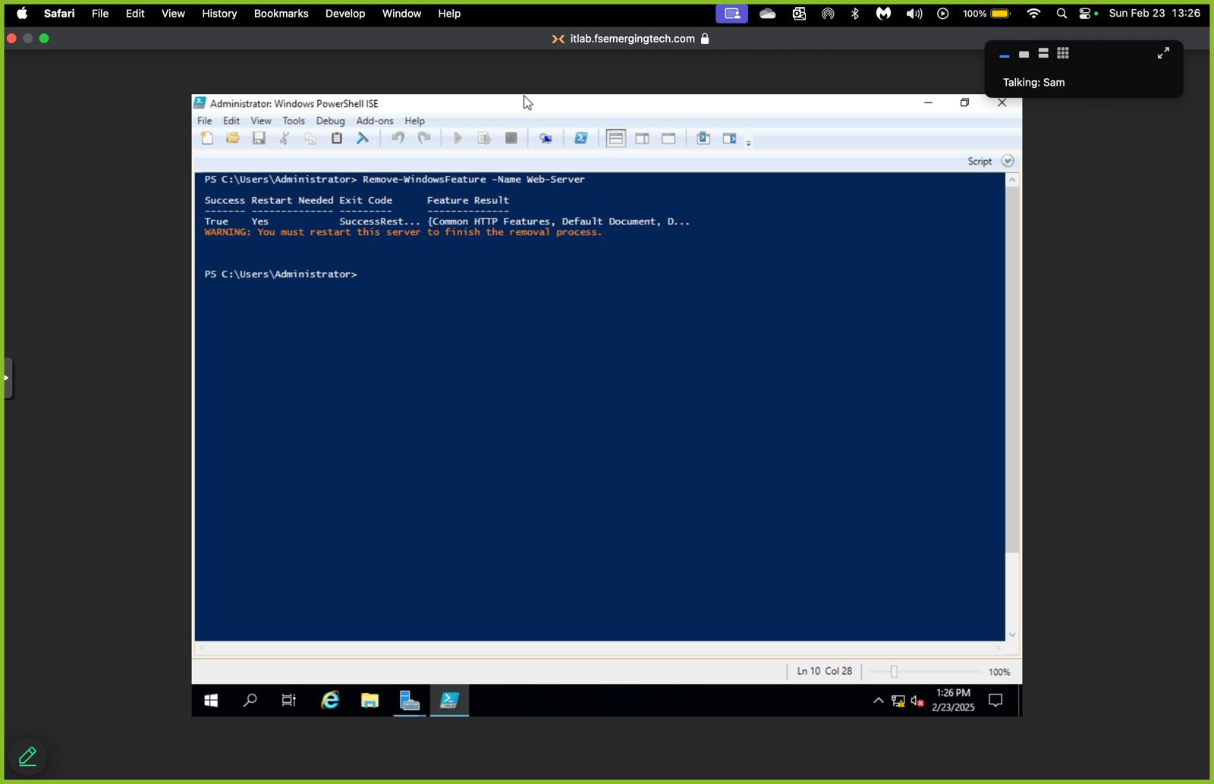

**Step 4:** Verify/confirm the change through the GUI that the role has been removed; take a screenshot for proof. The checkbox of Webserver (IIS) has been unchecked, meaning it has been installed.

